Raewyn
Caisley

Latest releases

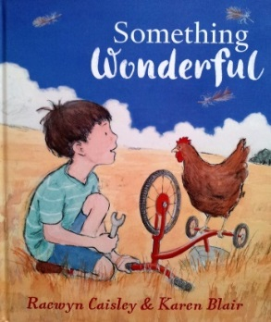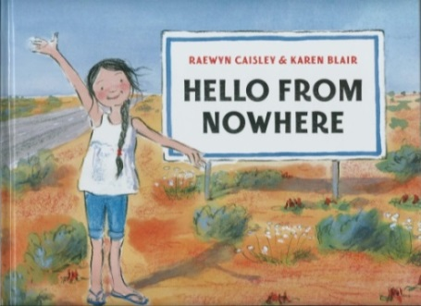
Penguin Random House Australia, 2016 Penguin Random House Australia, 2014
ISBN 9780670078455 ISBN 978 0 6700 7500 3

Something Wonderful. Dedicated to ‘all the creative thinkers’,
Sam’s story will inspire and empower the dreamer in us all.
Writing WA

Hello From Nowhere ‘makes you want to live within its pages.’
The West Australian

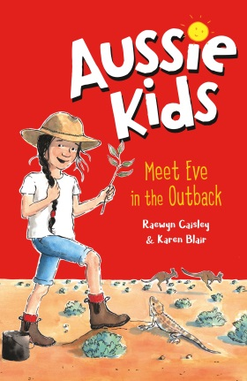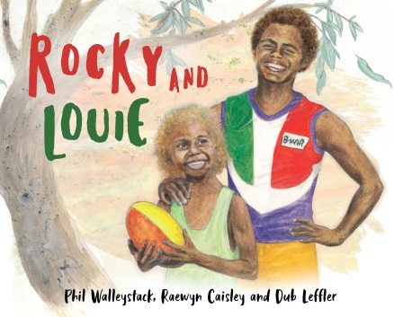
PenguinRandomHouse 2020 PenguinRandomHouse 2020
ISBN 9781760894108 ISBN 9780143786528

www.facebook.com/raewyncaisley raewyncaisley@gmail.com Ph: 08 62609001 mobile: 0424 221224
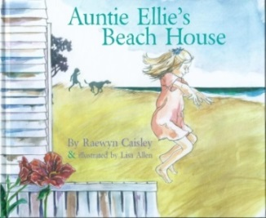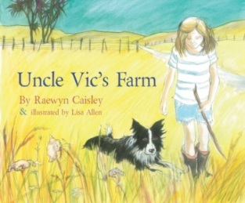
Duck Creek Press 2015 Duck Creek Press 2015
ISBN 978 1 877378 95 9 ISBN 9781 927305 13 3

Auntie Ellie’s Beach House named in top 50 books published worldwide in 2015!
Aussie Nibbles

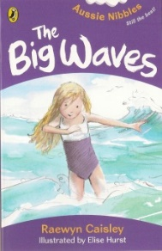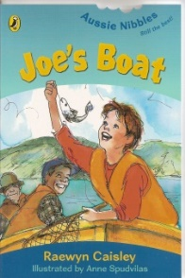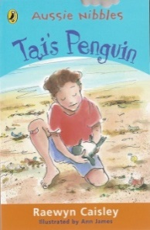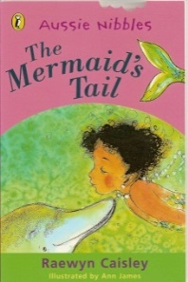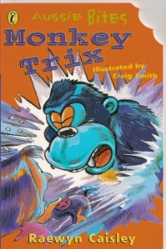

The Mermaid’s Tail, top selling Aussie Nibble of all time!
Monkey Trix, the first ever Aussie Bite!
Tai’s Penguin, shortlisted for the Premier’s Award!

Nibbles anthologies

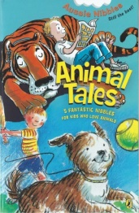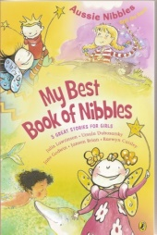
Tai’s Penguin lives on! The Mermaid’s Tail too!!

Books for older readers

Hachette’s SPORTS FICTION SERIES
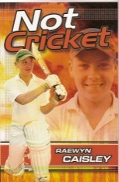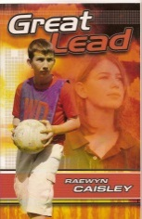

www.facebook.com/raewyncaisley raewyncaisley@gmail.com Ph: 08 62609001 mobile: 0424 221224

